ETST 380A2: War, Militarism, & GI Resistance
Benjamin Schrader
T/TH 12:30-1:45
Location: Aylesworth C108
Office: 255 SE Aylesworth
Office Hours: By Appointment

Course Description
With the wars in Iraq and Afghanistan winding down the Global War on Terror is shifting to a new type of warfare. With a shift in war, there is a need to understand not only what war is, but also the affects of war. This course will look to understand not only the affective attributes of war but also the causes of it as it seeks to understand how our everyday lives have become militarized and what that means for society. Finally this course will explore the excess of war, which is the veterans who suffer from the affects of war, and their fight against the war machine that continues to destroy all that comes into contact with it.

Course Standards
Every student at CSU has the ability to succeed in my course. The difference between success and failure in my class is a matter of attitude, effort, and initiative. There is a difference between passively listening to lectures and critically engaging with complex texts. There is a difference between regurgitating facts and actively applying new concepts, just as there is a difference between taking multiple-choice tests and writing sophisticated papers. In this sense, successful students will be those who embrace growth and hard work. They will overcome self-defeating behavior (i.e. skipping class, not reading, writing half-baked papers), make use of available resources, and turn freely to others for help.

The course will demand that its members read critically, participate actively, and write effectively. Most of all, it will ask students work with their fellow members to create an environment where ideas and arguments matter. On a more mundane note:
- Students are expected to attend every class, as attendance will be taken. I know unexpected things happen therefore each student is allotted 3 absences, no questions asked, except when slotted for a presentation. Beyond the 3 “free” absences, you will lose 5% of your final grade for every absence.
- Students should expect to be involved in each class. I will work hard to ensure that everyone has an opportunity to earn his or her performance points. In this regard, more than just showing up, you will need to offer meaningful contributions.
- Papers must be submitted via RamCT mail in a Word or pdf attachment before the start of class on the specified dates. Work submitted after that time will be penalized 10% per day.
- Students are expected to conduct themselves in a professional manner (i.e., respect your classmates, turn off cell phones, no outside work or reading, etc.). Those who fail to adhere to these basic guidelines will be removed from class
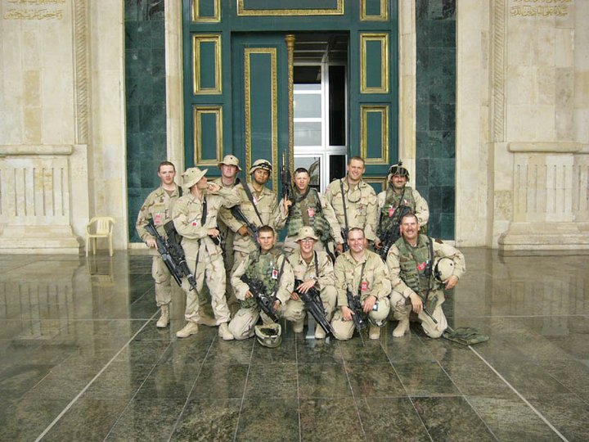
Reading Materials

All texts will be available on RamCT. You will need to have a well-marked hard or electronic copy in front of you to succeed in class.

Grading Criteria
This course is designed to enable students to become sophisticated/critical thinkers, speakers, and writers. As such, course grades will be comprised of four elements: Attendance (24%); Weekly Journals (26%); In-class participation (20%); Written Papers (30%). There is a total of 1000 points available for the class.

Attendance: As outlined above, Students are expected to attend every class, as attendance will be taken. I know unexpected things happen therefore each student is allotted 3 absences, no questions asked, except when slotted for a presentation. Beyond the 3 “free” absences, you will lose 5% of your final grade for every absence. Furthermore, because there are a number of movies and documentaries that will be shown in class, students are expected to stay awake through the entirety of the movie, if a student falls asleep in class they will be asked to leave and they will be counted as absent. There is a possible 240 Points available, therefore after three absences you will lose 50 points per absence, up to the entire 240 points.

***NOTE ON WHAT CONSTITUTES AN ABSENCE***
Being sick counts as an absence, I do not care if you have a doctor’s note. The only time I will not count you absent is if you are participating in a CSU sanctioned event, and have a note from your coach, supervisor, etc. OR some kind of major tragedy, to which come talk to me and we’ll figure it all out.

Weekly Journals: Each student is expected to turn a weekly journal that discusses what that weeks discussions, readings, movies, etc. made them think about. What does it mean to you? What does it mean for society? How did it make you feel? Do you buy it, or do you think it’s a bunch of crap? Students will have room to be creative here as there is no length requirement/limit, however, writing things like, “the reading was hard, and I didn’t get it,” or “I agreed with the movie, it was cool,” do not constitute a journal entry. Each journal entry is worth 20 points (13 entries=260 points), and they must be emailed to me by 2 PM, every Friday.

Class Participation: Only a portion of what you will gain from this course will be drawn from the instructor as the course has been designed to put students in charge of their learning (no spoon-feeding here). I expect that your classmates—via class discussions and group work—will play an instrumental role in your learning experience. To encourage this collaborative approach to learning, your participation grade is comprised of two categories: group discussants and daily contributions.

  - Readings: Beginning with Week 3, class discussions will be headed by teams of three or four students, depending on the size of the class. Each team will be responsible for presenting a reconstruction of the reading, unpacking (or minimally identifying) challenging sections and concepts, and posing provoking questions. Creativity is encouraged provided the aforementioned criteria are met. To be clear, THESE SHOULD NOT BE PLOT SUMMARIES; please engage critically with the text and create ways of drawing the class into a vibrant discussion. I will model this in the first two weeks so that student will have an idea as to what I want their presentations to look like. Students will be graded for their presentations, but also those who are not presenting will be graded on their participation (see daily contributions section below). Students will be expected to sign up for two presentations, each worth 50 points, for a total of 100 points.
  - Daily Contributions: One of the shortcomings associated with student-led discussions is that non-presenters can be duped into thinking they have the day off. I will help you avoid this pitfall by working to call upon each student in every class. Therefore, it is in your best interest to not only read thoroughly, but also come prepared with insightful questions and comments. While I do not demand that students have THE correct answer, you will need to offer a response that evinces a sufficient level of forethought. This is worth 100 points.
  - Therefore, this section is worth 200 points.

Written work: Each student will submit 3 papers throughout the entirety of the course (~5-6 pages, well-formed research question, professional writing style, footnotes, etc.). Students will turn in one paper per section of the course—so one paper for the “War” section, one for the “Militarism” section, and one for the “Veteran Resistance” section. Each paper is to take some of the concepts that are presented within that section of the course, make connections to current events, and make an argument. Each paper is due within a week of the conclusion of each section, so paper 1 is due during week 6, by (11:59 PM) Thursday February 27th. Paper 2 is due during week 12, by (11:59 PM) Thursday April 10th. Paper 3 is due a week after classes end, by (11:59 PM) Thursday May 15th. While these are the deadlines, you can turn your papers in at anytime during the appropriate section of the course. Each paper is worth 100 points, making this section worth 300 points.

ACADEMIC INTEGRITY AND STUDENT CONDUCT
Students are required to follow the CSU campus policies as listed in the course catalog or found here http://www.conflictresolution.colostate.edu/conduct-code. Students are required to be respectful of their classmates and refrain from disruptive behavior in the classroom and on campus. If you engage in cheating or plagiarism, you will receive an F (0.0) grade for the course and I will be forced to report you for academic dishonesty.

Plagiarism includes, but is not limited to, submitting, to satisfy an academic requirement, any document that has been copied in whole or in part from another individual’s work without identifying that individual; neglecting to identify as a quotation a documented idea that has not been assimilated into the student’s language and style; paraphrasing a passage so closely that the reader is misled as to the source; submitting the same written or oral material in more than one course without obtaining authorization from the instructors involved. If you can find it online, so can I. If you have questions regarding what does and does not constitute plagiarism, please ask me.

With that said, many people who plagiarize often do so out of desperation. Please come talk with me if you are feeling stressed or having problems with the assignments and we can work together in order to get you the resources in order to be successful.

STUDENTS WITH DISABILITIES
The Americans with Disabilities Act (ADA) is a federal anti-discrimination statute that provides comprehensive civil rights protection for persons with disabilities, including reasonable accommodation of their disabilities. If you have a disability requiring an accommodation, please let me know and contact the Resources for Disabled Students (RDS) Program in 100 General Services Building, visit their website http://rds.colostate.edu/, or call them at (970) 491-6385 (V/TDD).

Course Breakdown
Part I: WAR

Week 1: Introduction/Classical conceptions of War

T: 1/21 Tue: Course Introduction

Th: 1/23 Carl Von Clausewitz On War, Pgs: 13-44

Week 2: Reconceptualizing War

T: 1/28 Movie: Generation Kill

Th: 1/30 Movie: Generation Kill

Week 3: Purpose of War

T: 2/4 Michel Foucault “7 January 1976” Society Must Be Defended (New York: Picador, 2003)

Th: 2/6 Michel Foucault “17March 1976” Society Must Be Defended (New York: Picador, 2003)
Week 4: Violence, War, & Peace

T: 2/11 Michael Shapiro, Violent Cartographies Chap 1 Pgs: 1-40

Th: 2/13 Johan Galtung “Structural Violence”

Week 5: Contemporary War

T: 2/18 Manfred Steger, “The Rise of the Global Imaginary: Political Ideologies from the French Revolution to the Global War on Terror” Pgs: 213-248

Th: 2/20 Anne Jones, reading from “War is Not Over, When it’s Over” Pgs: 1- 14; 204-247.

PART II: MILITARISM
Week 6: Militarization of Everyday Life

T: 2/25 Cynthia Enloe From Maneuvers: “How Do They Militarize a Can of Soup?” Pgs: 1-34

Th: 2/27 Movie: Militainment
***PAPER #1 DUE BY 11:59 PM***

Week 7: Who gets Militarized? Everyone!

T: 3/4 Cynthia Enloe From Maneuvers, “Filling the Ranks” Pgs: 261-287

Th: 3/6 Gen. Smedley Butler, “War is a Racket”

Week 8: The Military as a Rape Ontology

T: 3/11 Cynthia Enloe From Maneuvers: “When Soldiers Rape” Pgs: 108-152

Th: 3/13 Cris Cuomo’s “War is Not Just an Event: Reflections on the Significance of Everyday Violence”

Week 9: Spring Break No Class

Week 10: War/violence Against Women

T: 3/25 Movie: The Invisible War

Th: 3/27 The Invisible War Discussion
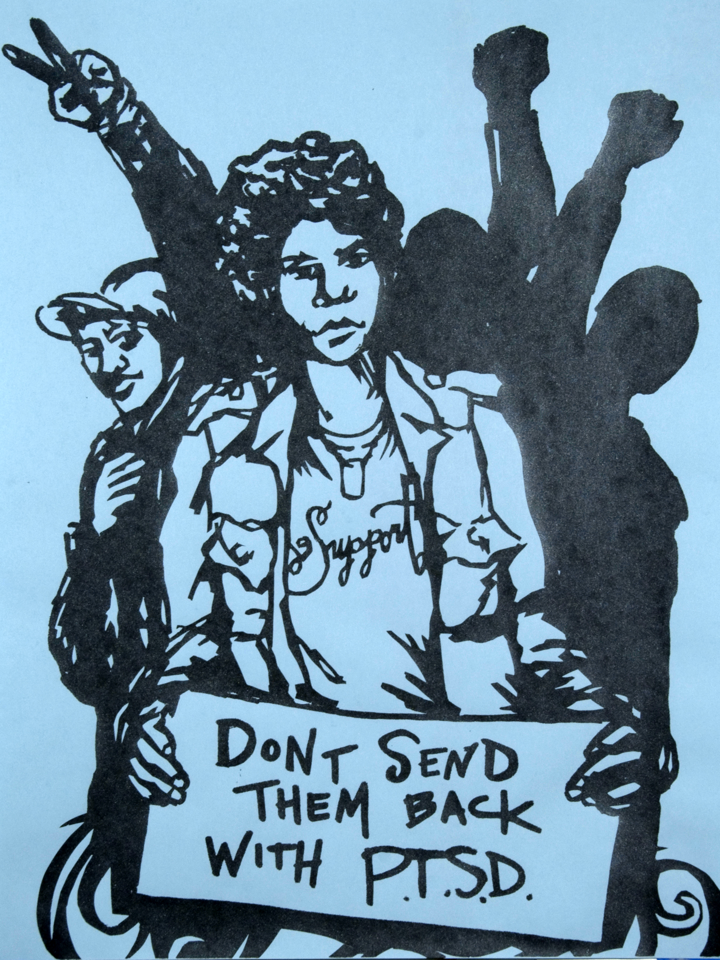
Week 11: Making Sense of Militarism

T: 4/1 Ruth Seifert: The Second Front: The Logic of Sexual Violence in Wars Finish Invisible War/discussion

Th: 4/3 IVAW Dispatches Zine

PART III: VETERAN RESISTANCE
Week 12: A History of Resistance

T: 4/8 Movie: Sir No Sir

Th: 4/10 Winter Soldier VVAW Panel
***PAPER #2 DUE BY 11:59 P.M.***

Week 13: Coming to Grips with the Truth

T: 4/15 Shay: “Learning About Combat Stress from Homer’s Illiad”

Th: 4/17 Dahr Jamail The Will To Resist, “Speaking Out” Pgs 69-94

Week 14: Who Fights

T: 4/22 Derek Sweetman “Bradley Manning, Collateral Murder, Truth, and Power.” http://www.unrestmag.com/bradley-manning-collateral- murder-truth-and-power/

Th: 4/24 Movie: THE ACTIVISTS: War, Peace, and Politics in the Streets on Vimeo http://vimeo.com/m/49732898

Week 15: The Cost of War

T: 4/29 Howard Zinn: It is not only Iraq that is occupied. America is too

Th: 5/1 Dahr Jamail The Will To Resist, “Suicide” 155-170.

Week 16: Conclusion

T: 5/6 Winter Soldier IVAW Panel

Th: 5/8 Wrap up
***FINAL PAPER DUE BY 11:59 P.M. 5/15***

